Principal Component Analysis (PCF) – Populism Illiberalism Authoritarianism
Oct 9

Most scales reversed. Higher values mean higher levels of P or I or A.
Z-scores, weighted data.

Index

PIA pooled – all in one basket: …………………………..p. 2
Populism (pooled): ……………………………………….p. 3
Populism (by country): …………………………………...p. 5
Illiberalism (pooled): ……………………………………..p. 6
Illiberalism (by country): …………………………………p. 8
Authoritarianism (pooled): ………………………………p. 10
Authoritarianism (by country): …………………………..p. 13
Correlations between factors: ……………………………p. 14
Correlations between factors and P2: …………………….p.15
Correlations between factors and other correlates: ………p.16
Alternative measure of Authoritarianism (7 items): ………...p. 17

Table 1. PIA pooled (all variables, all countries)

 |  | Illib. 1 | Illiberal 2 | Populist | Illiberal 3 | Auth. 1 | Auth. 2 | Auth. 3
 |  | Factor1 | Factor2 | Factor3 | Factor4 | Factor5 | Factor6 | Factor7 | Uniqueness
Variable | Proportion of explained variance | 0.12 | 0.11 | 0.07 | 0.07 | 0.06 | 0.06 | 0.05
std_P11_04 | Politics is ultimately a struggle between good and evil | 0.16 | -0.08 | 0.31 | 0.06 | 0.47 | 0.23 | 0.02 | 0.60
std_P11_05 | The will of the majority should always prevail… | 0.32 | 0.32 | 0.11 | 0.02 | 0.17 | 0.25 | -0.07 | 0.67
std_P11_06 | [Country] is pretty much run by a few big interests…. | -0.03 | 0.06 | 0.80 | 0.09 | 0.01 | -0.04 | -0.01 | 0.35
std_P11_07 | Politicians constantly over-complicate simple matters… | -0.02 | 0.07 | 0.77 | 0.04 | -0.05 | 0.14 | 0.03 | 0.38
std_P4_03 | Women should be prepared to cut down on paid work… | 0.50 | 0.20 | -0.07 | 0.12 | 0.27 | 0.04 | 0.00 | 0.64
std_P4_04 | Same‐sex marriages should be prohibited by law | 0.72 | 0.09 | -0.01 | 0.34 | -0.04 | 0.06 | 0.04 | 0.35
std_P4_05 | Women should be free to decide on matters of abortion (reversed) | 0.24 | 0.01 | 0.07 | -0.03 | 0.11 | -0.45 | 0.24 | 0.56
std_P4_06 | Teaching teenagers about tolerance towards transgender and homosexual… | 0.67 | 0.23 | -0.03 | 0.10 | -0.01 | 0.09 | 0.06 | 0.51
std_P4_07 | These days you cannot even say what you think about immigrants, women or gays… | 0.30 | 0.46 | 0.15 | -0.15 | -0.08 | 0.31 | 0.08 | 0.54
std_P12_01 | What our society needs is protection against international influences…. | 0.44 | 0.48 | 0.33 | -0.02 | 0.19 | 0.17 | -0.01 | 0.39
std_P12_02 | Leaders should always follow the interests of their country… | 0.39 | 0.38 | 0.38 | -0.05 | 0.15 | 0.16 | -0.04 | 0.51
std_P12_03 | It is impossible for an organisation to serve the interests… | 0.37 | 0.30 | 0.30 | -0.10 | 0.15 | 0.06 | -0.08 | 0.62
std_P12_04 | Those who claim that there are powerful organisations in the world which conspire… | 0.44 | 0.21 | 0.36 | 0.02 | 0.28 | 0.04 | -0.01 | 0.51
std_P12_05 | These days the leading contribution white people have made to human culture | 0.49 | 0.48 | 0.17 | -0.05 | 0.07 | 0.13 | 0.00 | 0.48
std_P6 | Immigrants bad for the economy | 0.03 | 0.81 | 0.03 | 0.21 | 0.02 | 0.02 | -0.02 | 0.33
std_P7 | Immigrants bad for culture | 0.07 | 0.84 | 0.04 | 0.15 | 0.01 | 0.06 | 0.01 | 0.27
std_P5_01 | No Muslim neighbours | 0.10 | 0.46 | 0.05 | 0.58 | -0.02 | 0.06 | -0.03 | 0.42
std_P5_02 | No Jewish neighbours | 0.14 | 0.10 | 0.09 | 0.70 | 0.10 | 0.01 | -0.05 | 0.46
std_P5_04 | No homosexual neighbours | 0.52 | -0.03 | 0.04 | 0.57 | -0.05 | -0.01 | 0.01 | 0.41
std_P5_06 | No other race neighbours | 0.11 | 0.30 | 0.03 | 0.68 | 0.03 | 0.01 | 0.01 | 0.42
std_P2_10 | Important for democracy ....that people obey their rulers? | 0.06 | -0.07 | -0.02 | -0.03 | -0.05 | 0.15 | 0.78 | 0.36
std_P2_11 | Important for democracy ....that religious authorities ultimately interpret the laws? | -0.02 | 0.07 | 0.04 | -0.01 | 0.19 | -0.06 | 0.73 | 0.37
std_P3 | How acceptable for you would it be for the [Country] to have a strong leader… | 0.00 | 0.14 | -0.08 | 0.05 | 0.69 | -0.13 | 0.19 | 0.45
std_P11_08 | The government should be able to bend the law in order to solve pressing social… | 0.12 | -0.04 | 0.02 | 0.01 | 0.66 | 0.32 | -0.04 | 0.47
std_P4_01 | Obedience and respect for authority are the most important virtues children… | 0.26 | 0.10 | -0.01 | 0.00 | 0.19 | 0.65 | 0.16 | 0.40
std_P4_02 | People who break the law should be given much harsher sentences… | 0.02 | 0.19 | 0.21 | 0.06 | 0.04 | 0.66 | 0.07 | 0.43
std_P4_08 | Those who don’t believe in God are not suitable for governing this country | 0.61 | -0.10 | -0.11 | 0.18 | 0.26 | 0.02 | 0.01 | 0.52
Scale reliability coefficient: 0.8334
- In what follows, we will consider the ‘neighbours question’ (tolerance towards Muslims, Jews, homosexuals and people of other race) a correlate rather than as core characteristic of illiberalism. This is of course debatable, but as it loads on a separate factor not strongly related to the other questions on intolerance towards minorities, we took this decision.
- We also run a different set of analyses in which we included the normative notions of democracy (P2), confirming that these do not load well on PIA factors and thus seem to not form part of the core dimensions/indicators of PIA. We will leave them out as correlates, just as the two variables related to Welzel’s authoritarian notions of democracy (P2_10, std_P2_11) as these also load on a separate factor (7 in Table 1).

Populism (pooled)

Agreement with:
P11_04. Politics is ultimately a struggle between good and evil
P11_05. The will of the majority should always prevail, even over the rights of minorities
P11_06. [Country] is pretty much run by a few big interests looking out for themselves
P11_07. Politicians constantly over-complicate simple matters instead of effectively solving them

Correlations

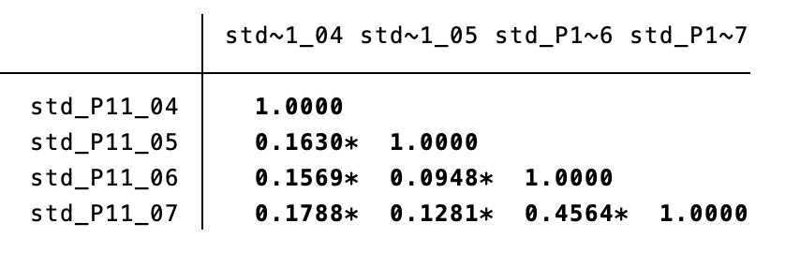

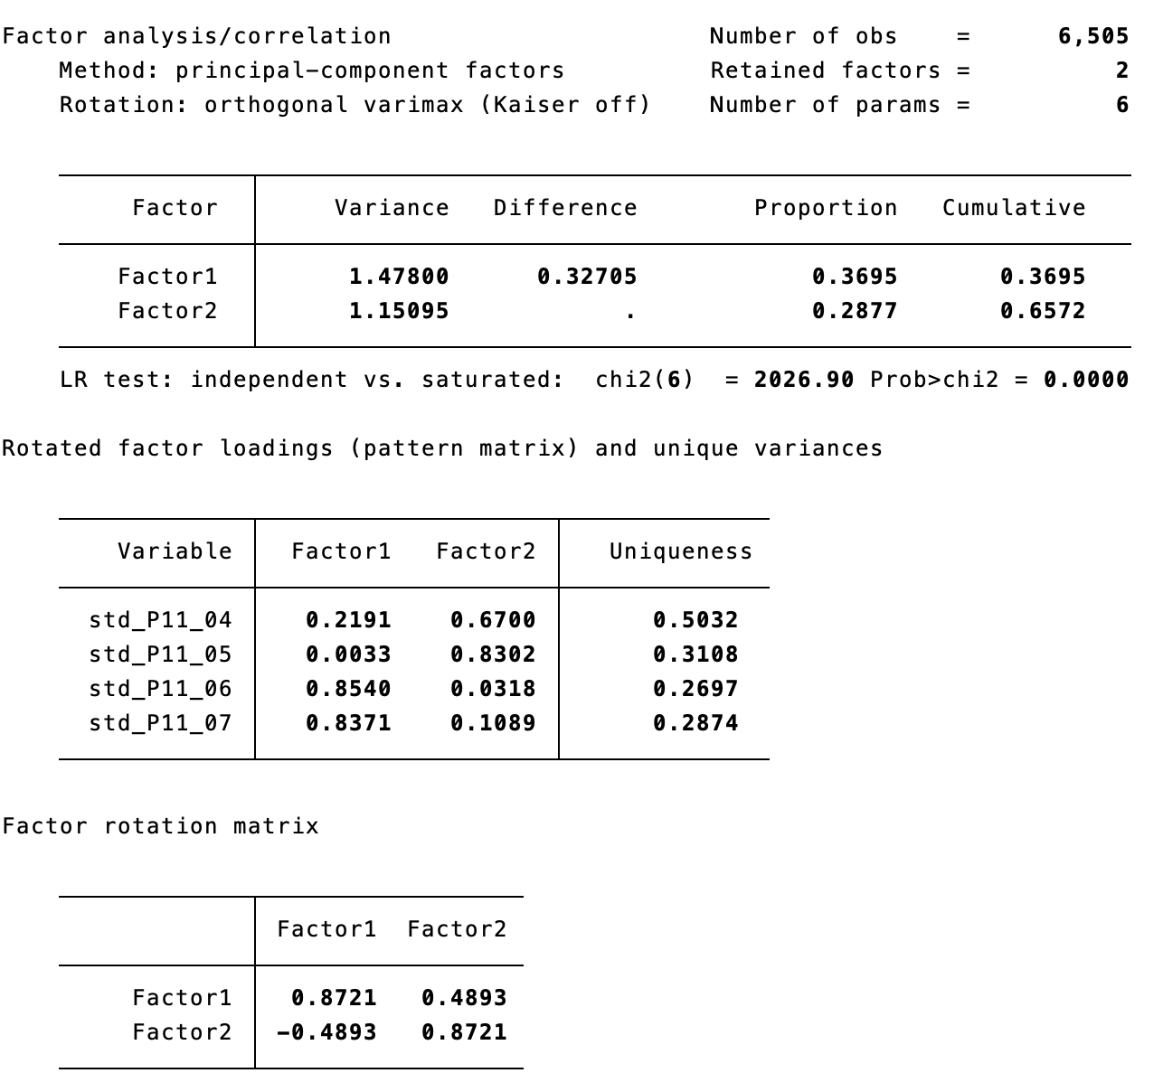
Scale reliability coefficient: 0.4938

2 Factors:

Factor 1) Manicheism and majoritarianism
Agreement with:
P11_04. Politics is ultimately a struggle between good and evil
P11_05. The will of the majority should always prevail, even over the rights of minorities

Factor 2) Anti-elitism and simplism
P11_06. [Country] is pretty much run by a few big interests looking out for themselves
P11_07. Politicians constantly over-complicate simple matters instead of effectively solving them

Populism (by country)

IT – also two factors, very similar to pooled model, alpha=0.3382

CZ – only one factor in CZ (higher loadings of P11_06 and P11_07), alpha=0.5673

AT – only one factor in AT (higher loadings of P11_06 and P11_07), alpha=0.6265

FR – also two factors, similar to the pooled model, alpha=0.3938

GB – only one factor in GB (higher loadings of P11_06 and P11_07), alpha=0.4568

HU – also two factors, very similar to pooled model, alpha=0.4992

PL – also two factors, very similar to pooled model, alpha=0.4982

Illiberalism (Pooled)

P4_03. Women should be prepared to cut down on paid work for the sake of the family [ESS 5 G4]
P4_04. Same‐sex marriages should be prohibited by law [EES 09 Q58]
P4_05. Women should be free to decide on matters of abortion [EES 09 Q60] [Reversed]
P4_06. Teaching teenagers about tolerance towards transgender and homosexual minorities in schools can cause harm
P4_07. These days you cannot even say what you think about immigrants, women or gays without being called prejudiced
P12_01. What our society needs is protection against international influences, not further opening up
P12_02. Leaders should always follow the interests of their country, even if this means going against international rules
P12_03. It is impossible for an organisation to serve the interests of our nation if most of its funding comes from foreign sources
P12_04. Those who claim that there are powerful organisations in the world which conspire against [Country] have a good point.
P12_05. These days the leading contribution white people have made to human culture is being downplayed
P6. Immigrants bad for the economy
P7. Immigrants bad for culture

Correlations
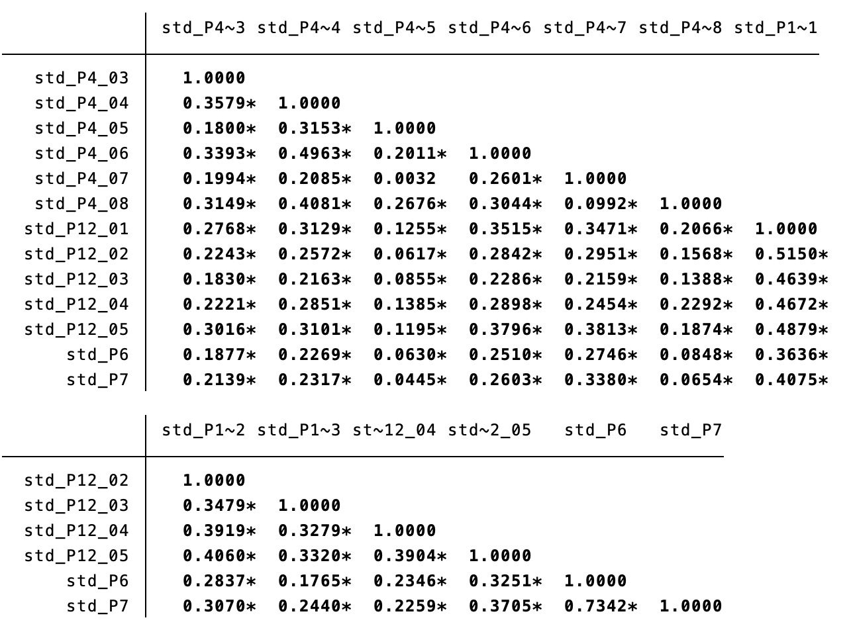
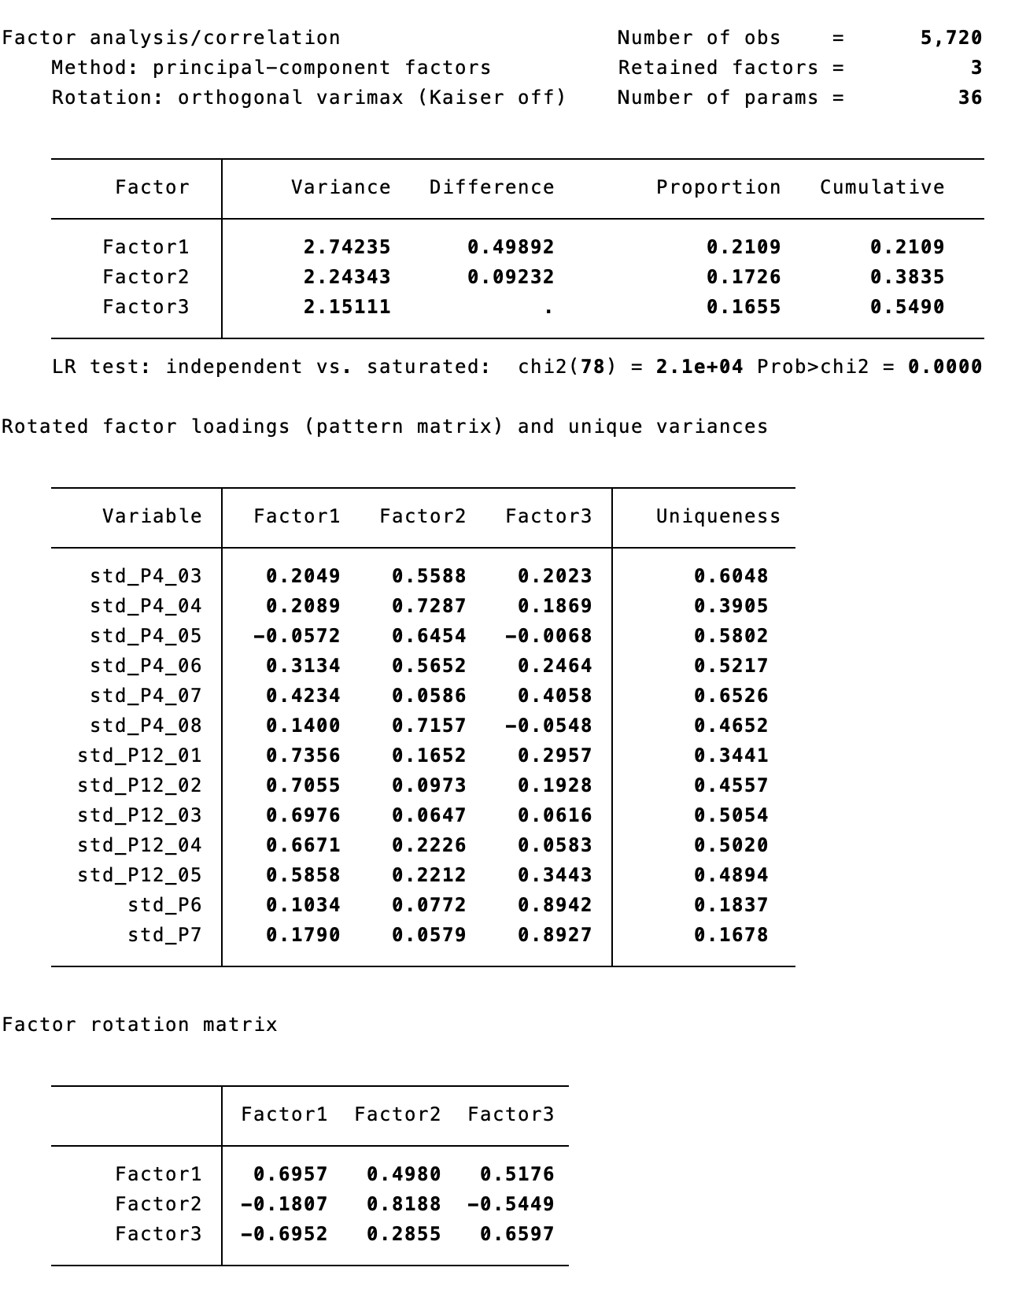
Scale reliability coefficient: 0.8239

F1. Parochialism
P12_01. What our society needs is protection against international influences, not further opening up
P12_02. Leaders should always follow the interests of their country, even if this means going against international rules
P12_03. It is impossible for an organisation to serve the interests of our nation if most of its funding comes from foreign sources
P12_04. Those who claim that there are powerful organisations in the world which conspire against [Country] have a good point.
P12_05. These days the leading contribution white people have made to human culture is being downplayed
[P4_07. These days you cannot even say what you think about immigrants, women or gays without being called prejudiced]

F2. Traditionalism/Social-conservatism/Disrespect for minority rights
P4_04. Same‐sex marriages should be prohibited by law
P4_08. Those who don’t believe in God are not suitable for governing this country
P4_05. Women should be free to decide on matters of abortion [Reversed]
P4_06. Teaching teenagers about tolerance towards transgender and homosexual minorities in schools can cause harm
P4_03. Women should be prepared to cut down on paid work for the sake of the family

F3. Nativism
P6. Immigrants bad for the economy
P7. Immigrants bad for culture
[P4_07. These days you cannot even say what you think about immigrants, women or gays without being called prejudiced]

Illiberalism (by country)

IT – also three factors, very similar to pooled model, alpha= 0.8136

CZ – also three factors, different from the pooled model (F1 = P12_03, P12_05, P4_07, P12_02, P12_01, P4_06, P4_03 - mix of pooled F1 and F2; F2= P6 P7 - nativism, same as F3 in pooled; F3= P4_08, std_P4_05 – religious fundamentalism, makes sense that it works different in CZ), alpha=0.8156

AT – two factors, quite similar to pooled model, but F1 here incorporates nativism to parochialism (F1 in Austria = F1 & F3 in pooled model), alpha= 0.8546

FR – four factors, somewhat similar to the pooled model but in another order, F1=nativism, F2=traditionalism/social-conservatism/disrespect for minority rights, F3=parochialism, and P4_05 (abortion) loads as a separate factor 4 (*double-check coding), alpha= 0.7714

GB – also three factors, quite similar to pooled model, F1= parochialism, F2=nativism, F3=traditionalism/social-conservatism/disrespect for minority rights, alpha= 0.8274

HU – four factors, quite similar to pooled model, F1=parochialism, F2=nativism, F3=traditionalism/social-conservatism/disrespect for minority rights, but P4_07 (political correctness) loads as a separate factor 4, alpha= 0.8284

PL – also three factors, very similar to pooled model, alpha=0.8504

Authoritarianism (Pooled)

P3. How acceptable for you would it be for the [Country] to have a strong leader who is above the law?
P11_08. The government should be able to bend the law in order to solve pressing social and political problems
P4_01. Obedience and respect for authority are the most important virtues children should learn [ESS 10 B38]
P4_02. People who break the law should be given much harsher sentences than they are these days [ESS 5 D33]

Correlations
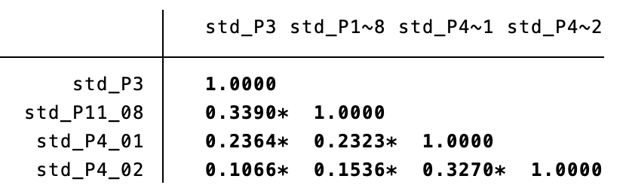

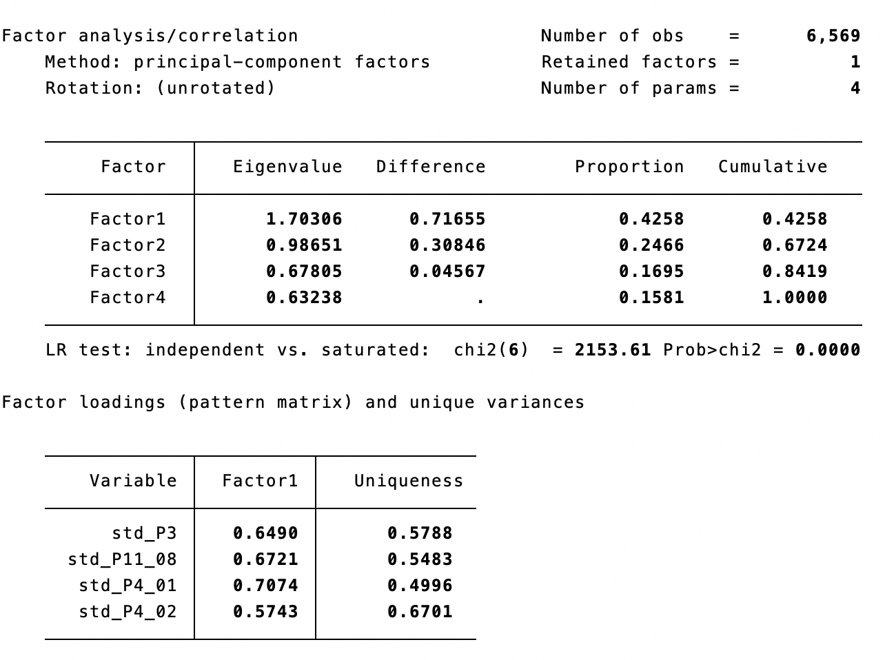

Factor 1
P4_01. Obedience and respect for authority are the most important virtues children should learn
P11_08. The government should be able to bend the law in order to solve pressing social and political problems
P3. How acceptable for you would it be for the [Country] to have a strong leader who is above the law?
P4_02. People who break the law should be given much harsher sentences than they are these days

Scale reliability coefficient: 0.4824

AUTHORITARIANISM BY COUNTRY

IT – also one factor, very similar to pooled model, alpha= 0.4843

CZ – also one factor, very similar to pooled model, alpha= 0.4202

AT – also one factor, very similar to the pooled model, alpha= 0.5273

FR – two factors, F1 = Obedience (P4_01) & Punitiveness (P4_02), load separately from F2= P3 (strong leader) + P11_08 (bend law), alpha= 0.4645

GB – two factors, just as in FR, F1 = Obedience (P4_01) & Punitiveness (P4_02), load separately from F2= P3 (strong leader) + P11_08 (bend law), alpha= 0.4615

HU – two factors, just as in FR, F1 = Obedience (P4_01) & Punitiveness (P4_02), load separately from F2= P3 (strong leader) + P11_08 (bend law), alpha= 0.4561

PL – two factors, just as in FR, F1 = Obedience (P4_01) & Punitiveness (P4_02), load separately from F2= P3 (strong leader) + P11_08 (bend law), alpha= 0.4137

//// Correlations between factors

f1_POP_antielite_simple
f2_POP_manichean_majoritarian
f1_ILL_Parochialism
f2_ILL_Trad_Cons_Intoler
f3_ILL_Nativism
f1_AUTH

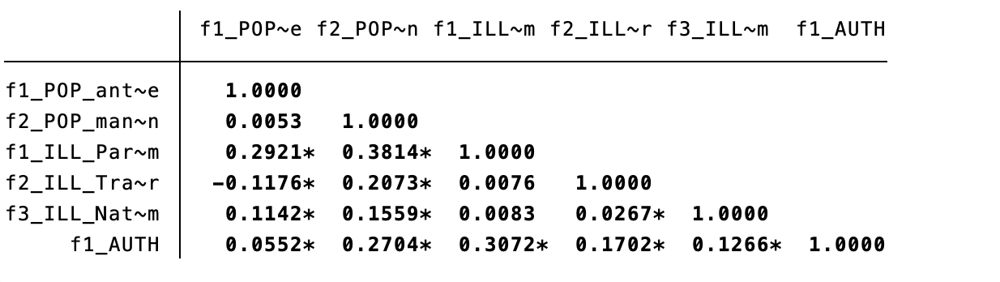

//// Correlations between factors and P2 (0-10, not standardized)
 |  | f1_POP_antielite_simple | f2_POP_manichean_majoritarian | f1_ILL_Parochialism | f2_ILL_Trad_Cons_Intoler | f3_ILL_Nativism | f1_AUTH
referendum | P2_01 | 0.2902* | 0.0983* | 0.2002* | -0.0808* | -0.004 | 0.0591*
people>elite | P2_02 | 0.2631* | 0.0493* | 0.1780* | -0.0783* | -0.0453* | 0.0109
people's will | P2_03 | 0.1868* | 0.0855* | 0.1563* | -0.0799* | -0.0381* | 0.0294*
free media | P2_04 | 0.1623* | -0.0891* | -0.0229 | -0.1950* | -0.0861* | -0.1656*
minorities' rights | P2_05 | 0.0321* | -0.1393* | -0.1052* | -0.1980* | -0.3213* | -0.0894*
courts equally | P2_06 | 0.1197* | -0.0819* | -0.0161 | -0.1874* | -0.0871* | -0.1028*
freedom of protest | P2_07 | -0.005 | -0.0516* | -0.0491* | -0.1109* | -0.1673* | -0.0712*
everyone votes | P2_08 | -0.002 | 0.0025 | 0.0537* | -0.0921* | -0.1211* | -0.0562*
religious symbols | P2_09 | -0.0570* | -0.0576* | -0.0796* | 0.0568* | -0.2836* | -0.0243
obey rulers | P2_10 | -0.1258* | 0.1172* | 0.0913* | 0.1232* | -0.0981* | 0.2433*
religious laws | P2_11 | -0.0722* | 0.1646* | 0.1257* | 0.2362* | -0.1251* | 0.2283*

//// Correlations between factors and other correlates (standardized)
 |  | f1_POP_antielite_simple | f2_POP_manichean_majoritarian | f1_ILL_Parochialism | f2_ILL_Trad_Cons_Intoler | f3_ILL_Nativism | f1_AUTH
No Muslims | std_P5_01 | 0.0953* | 0.1836* | 0.1991* | 0.1791* | 0.3798* | 0.0899*
No Jews | std_P5_02 | 0.0707* | 0.1374* | 0.1258* | 0.2381* | 0.1603* | 0.0762*
No homosexuals | std_P5_04 | 0.0246* | 0.1447* | 0.1605* | 0.4409* | 0.1208* | 0.0971*
No other race | std_P5_06 | 0.0479* | 0.1568* | 0.1438* | 0.1988* | 0.2812* | 0.0703*
Reduce income diff | std_P11_01 | 0.3225* | 0.0195 | 0.1019* | -0.0488* | -0.0643* | 0.0858*
Family & Nation | std_P11_02 | 0.1370* | 0.3496* | 0.4139* | 0.2920* | 0.1901* | 0.2567*
Relative deprivation | std_P11_03 | 0.1806* | 0.1985* | 0.1689* | 0.1529* | 0.0842* | 0.1265*
Technocracy | std_P11_09 | 0.2895* | 0.1106* | 0.1107* | -0.0048 | 0.0141 | 0.0767*
Nationalism | std_P12_06 | -0.1165* | 0.2020* | 0.2629* | 0.1327* | -0.0469* | 0.1267*
Representation | std_P16 | -0.3676* | 0.0533* | -0.0671* | 0.1000* | -0.2045* | -0.016
Responsiveness | std_P17 | 0.3685* | 0.0522* | 0.1278* | -0.1041* | 0.2175* | 0.0017
Generalized trust | std_P9 | -0.2322* | -0.0855* | -0.1371* | -0.0262* | -0.4041* | -0.0918*
Trust in parliament | std_P10_01 | -0.4679* | 0.0238 | -0.0765* | 0.0866* | -0.2926* | 0.0181
Sat demo | std_P14_02 | -0.4270* | 0.0328* | -0.0736* | 0.0389* | -0.2695* | -0.017
Support for EU unif | std_P20 | -0.1583* | -0.1821* | -0.3804* | -0.1125* | -0.4275* | -0.1033*

/////////////////////////////////////////////
Alternative measure of AUTHORITARIANISM

Including Welzel’s authoritarian notions of democracy (P2_10, P2_11) and P4_08 (Those who don’t believe in God are not suitable for governing this country)

Authoritarianism (Pooled)

Important for democracy:
P2_10....that people obey their rulers?
P2_11....that religious authorities ultimately interpret the laws?

P3. How acceptable for you would it be for the [Country] to have a strong leader who is above the law?
P11_08. The government should be able to bend the law in order to solve pressing social and political problems
P4_01. Obedience and respect for authority are the most important virtues children should learn [ESS 10 B38]
P4_02. People who break the law should be given much harsher sentences than they are these days [ESS 5 D33]
P4_08. Those who don’t believe in God are not suitable for governing this country

Correlations
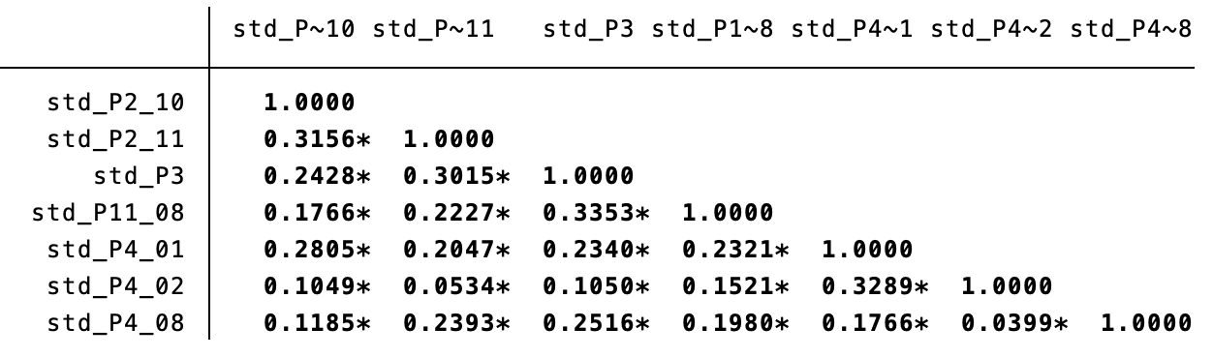

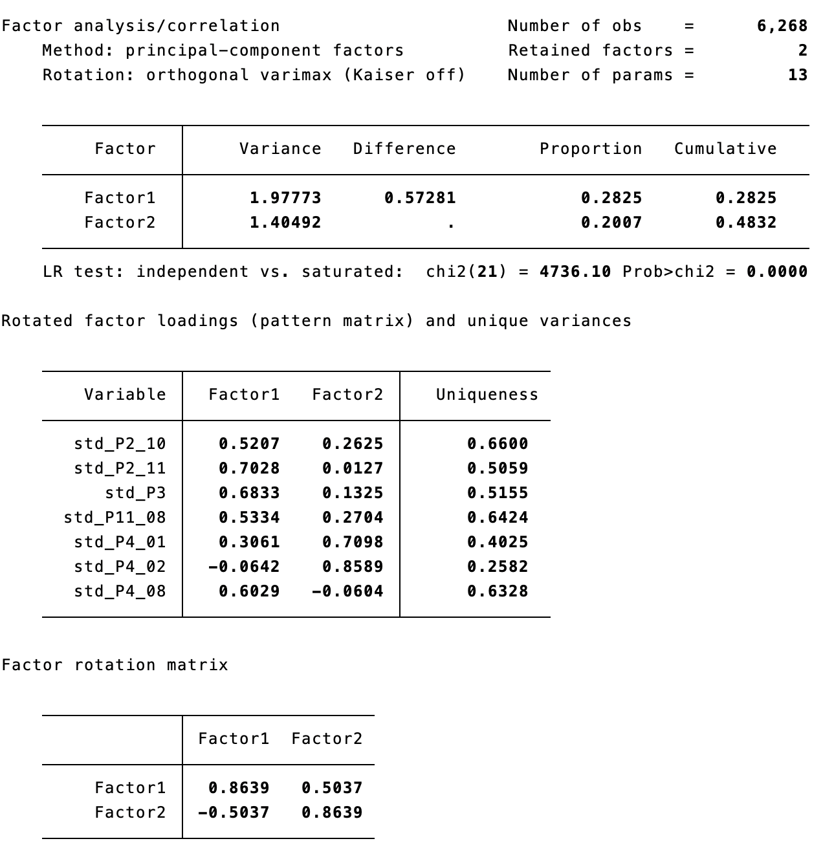

Scale reliability coefficient: 0.5140

2 Factors
Factor 1 (Institutional/Strong leader/God)
P2_10....that people obey their rulers?
P2_11....that religious authorities ultimately interpret the laws?
P3. How acceptable for you would it be for the [Country] to have a strong leader who is above the law?
P11_08. The government should be able to bend the law in order to solve pressing social and political problems
P4_08. Those who don’t believe in God are not suitable for governing this country

Factor 2 (Authority/Socialization/Punitiveness)
P4_01. Obedience and respect for authority are the most important virtues children should learn
P4_02. People who break the law should be given much harsher sentences than they are these days

AUTHORITARIANISM BY COUNTRY

IT – also two factors, similar to pooled model, but P11_08 (bend law) loads better on the second factor, alpha=0.4735

CZ – also two factors, but with different loadings (F1= P3, P11_08, P4_01, P4_02, P4_08; F2= P2_10, P2_11, and also P3, P11_08), alpha=0.4457 [*Problems with religious aspects in CZ?]

AT – also two factors, very similar to the pooled model, alpha=0.5733

FR – also two factors, very similar to the pooled model, alpha=0.4430

GB – also two factors, similar to the pooled model, but P2_10 (obey rulers) loads better on the first factor, alpha=0.5456

HU – also two factors, very similar to the pooled model, P11_08 (bend law) has no relationship with F2, while in the pooled model it does, alpha=0.5253

PL – also two factors, similar to the pooled model, but P4_08 (God and government) loads better on the second factor, P11_08 (bend law) has no relationship with F2, while in the pooled model it does, alpha=0.5160

